

TOPIC: **“NUMERICAL INTERGRATION”**

Group Members:

# Saad Ismail (16k-4060)

# Mehdi Raza Rajani (16k-3904)

# Daniyal Raza Khuwaja (16k-3952)

# Shakeeb Hussain Siddiqui (16k-4043)

# **What is Numerical Integration?**

In numerical analysis, numerical integration constitute a broad family of algorithms for calculating the numerical values of definite integral, and by extension, the term is also sometimes used to describe the numerical solution of differential equations. The basic problem considered by numerical integration is to compute an approximate solution to a definite integral. It is different from analytical integration in two ways: first it is an approximation and will not yield an exact answer; Error analysis is very important aspect in numerical integration. Second it does not produce an elementary function with which to determine the area given any arbitrary bounds; it only produces a numerical value representing an approximation of area.

# **History:**

The beginning of numerical integration have its roots in antiquity.

* Greek quadrature of the circle by means of inscribed and circumscribed regular polygons.
* Sum of an infinitesimal area over a finite range.

Newton formalized the concept of numerical integration:

This process broken down was taking a known area and overlapping it with an unknown area to approximate the area of the unknown shape. One could improve accuracy by choosing a better fitting shape. Later methods decided to improve upon estimating area under a curve decide to use more polygons but smaller in area. Such an example is the use of rectangles evenly spaced under a curve to estimate the area.

# **Closed Newton Cotes Formula:**

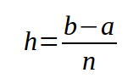

## Trapezoidal Rule ( n = 1 ):

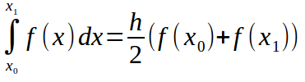

## Simpson 1/3 Rule ( n = 2 ):

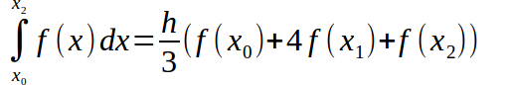

## Simpson 3/8 Rule ( n = 3 ):

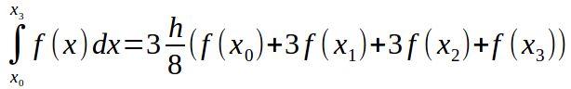

## Boole’s Rule ( n = 4 ):

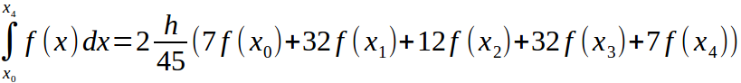

# **Open Newton Cotes Formula:**

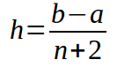

## Midpoint Rule ( n = 0 ):

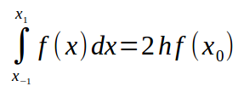

## ( n = 1 ):

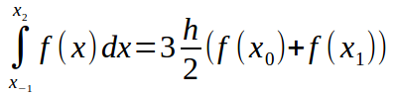

## ( n = 2 ):

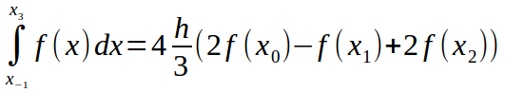

## ( n = 3 ):

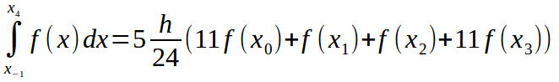

# **Algorithm:**

# **Open Newton Cotes Formula:**

## Midpoint Rule ( n = 0 ):

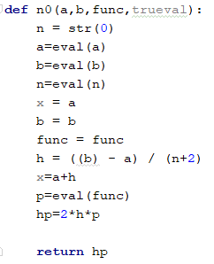

## ( n = 1 ):

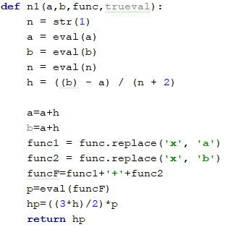

## ( n = 2 ):

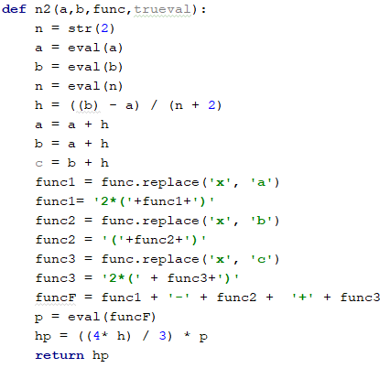

## ( n = 3 ):

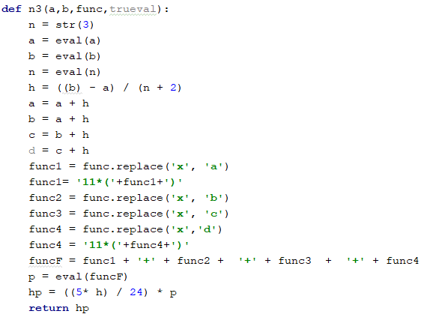

# **Closed Newton Cotes Formula:**

## Trapezoidal Rule ( n = 1 ):

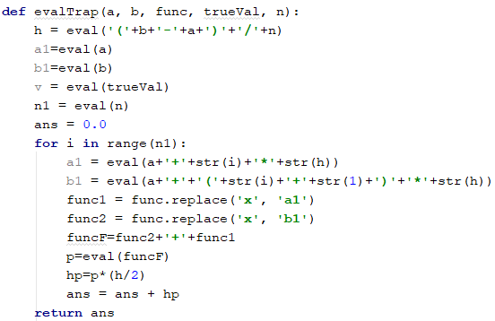

## Simpson 1/3 Rule ( n = 2 ):

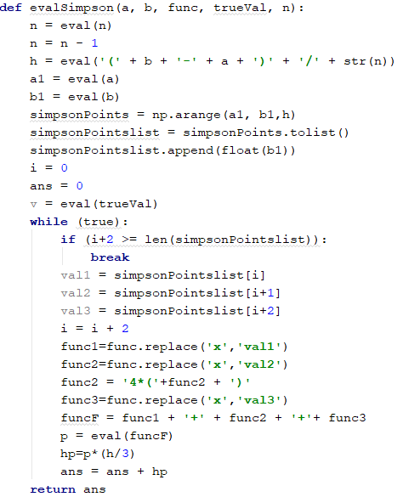

## Simpson 3/8 Rule ( n = 3 ):

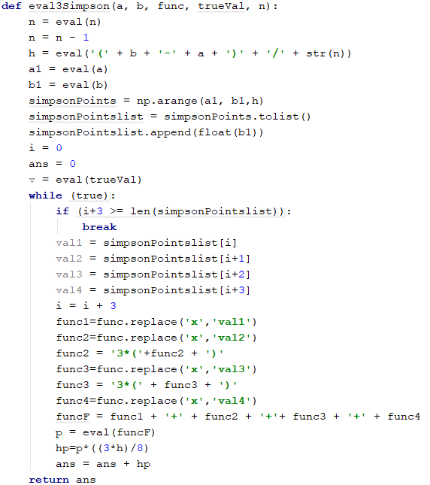

## Boole’s Rule ( n = 4 ):

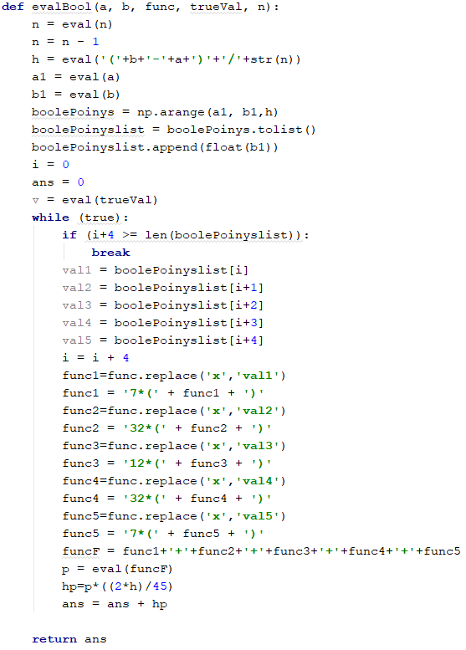

# **Screen Shots:**

## Closed Newton Cotes Formula:

## C:\Users\Mehdi Raza Rajani\Downloads\closed-function.png

## Closed Newton Cotes Formula (TABULAR):

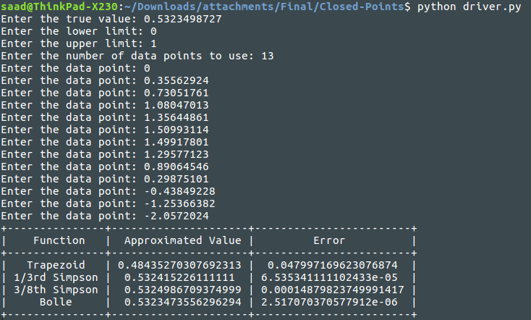

## Open Newton Cotes Formula:

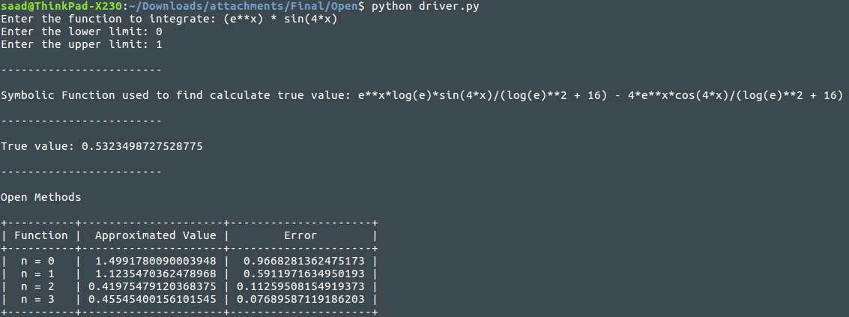

# **Summary:**

In this project we have defined why numerical integration is used, its comparison with analytical integration, what its background is, and what type of formulas are used in numerical integration. Mathematicians who contributed in numerical integration, though its computing methods so it’s all programs are made and ran successfully with appropriate outputs.